**E-WASTE MANAGEMENT SYSTEM**

**Abstract:**

During the last few decades, with the high-speed upgrade of electronic products, electronic waste (e-waste) has become one of the fastest growing wastes of the waste stream. A larger amount of electronic equipment’s is being wasted and causing a lot of cost to remanufacture it, which in turn effects the customer (People). The E-waste management System helps the customer/owner to easily identify the specific problem encountered in the Electronic device and resolve its efficiently.

Hear the idea is to collect and separate all the components from the motherboard which is working and not working one. Working components are used in another devices and not working components are used for recycling to get precious materials. Here we are taking motherboard components.

**INTRODUCTION:**

E-waste, also referred to as e garbage, is a massive problem in all countries worldwide. The electrical and electronic equipment market (EEE) is strongly bound to global growth. Greater disposable incomes, growing populations and mobility, and growing industrialization in different regions of the world are all leading to rising EEE levels. EEE is disposed of after usage, resulting in a waste stream involving toxic and valuable materials. E-waste, or Waste Electrical and Electronic Equipment, is the name given to this type of waste (WEEE).

EEE contains a wide scope of devices having circuitry or electrical components that require electricity or a battery (Step Initiative 2014). Nearly every single family or business uses products such as basic kitchen appliances, toys, musical equipment, and information and communication technology (ICT) such as mobile phones, laptops, and so forth.

EEE are increasingly employed in transportation, health, security systems, and energy generators, such as photovoltaics, in addition to regular household and corporate application. Traditional objects, such as clothing and furniture, are increasingly containing electrical components and so contributing to the global e-waste problem. EEE is increasingly being used in the growing Internet of Things (IoT) industry, such as sensors or gadgets related to the concept of the "smart house" or "smart city."

Any equipment that uses an electronic power source that has reached its end-of-life, according to the OCED (Organization for Economic Cooperation and Development), falls under WEEE. WEEE (waste from electronic and electrical equipment) is a unique type of waste that has gotten a lot of attention in the last 15 years.

Today, India's information technology (IT) has a strong global footprint, thanks in large part to the software industry. More recently, legislative changes have resulted in a massive influx of leading multinational corporations (MNCs) to India to build up manufacturing, R&D, and software development facilities.

Starting with 13 IT organizations in 1991, Bangalore currently has almost 3000 IT business is going world-class infrastructure. Bangalore's phenomenon is being repeated in several other Cities across india, including Chennai, Mumbai, Hyderabad, Pune, and Gurgaon. This sequential design process in the IT industry has resulted in a waste disposal issue.

Three categories of WEEE account for almost 90% of the total waste generation, which includes3 42 % large house hold appliances, 34 % ICT equipment and 14 % consumer electronics.

**Sources of e-waste**

**Manufacturer:** According to surveys conducted about 50% of PC’s which are sold all over the country are basically from the secondary market and are reassembled on the old components. The rest of market share cover by MNC’s (30%) and Indian brands (20%)24 . Besides manufacturers are major contributors of e-waste. The waste consists of defective IC chips, motherboards, CRTs and other peripheral items produced during the production process. It also includes defective PCs under guarantee procured from consumers as replacement items.

**Consumer:** About 22% of junk computers are generated from Indian household25 . The routine process of getting rid of obsolete computers include exchanging from retailers or pass on the same to friends or relatives. The business sector accounts for 78% of all installed PC's in India25. The junk computers from business sector are often sold during auction or sometimes donated to educational institutes or charitable institutions for reuse.

**Import of e-waste:** Import of e-waste is legally prohibited no doubt the reports prove that lots of e-waste is imported from abroad. The ministry of environment has no data related to import of e-waste but above says that 100% control of the borders is not possible.

|  |  |  |
| --- | --- | --- |
| S. No. | States | WEEE (Tones) |
| 1 | Maharashtra | 20270.59 |
| 2 | Tamil Nadu | 13486.24 |
| 3 | Andhra Pradesh | 12780.33 |
| 4 | Uttar Pradesh | 10381.11 |
| 5 | West Bengal | 10059.36 |
| 6 | Delhi | 9729.15 |
| 7 | Karnataka | 9118.74 |
| 8 | Gujarat | 8994.33 |
| 9 | Madhya Pradesh | 7800.62 |
| 10 | Punjab | 6958.46 |

Fig: E- Waste / WEEE Generation in Top Ten Cities

The Massive Amount of E-Waste Which Is not Recycled Can Be linked to:

**Storage:** Most aged electrical devices are maintained in people's homes as a daily ritual, which reduces their chances of being employed efficiently.

**Vaporization:** The majority of Indian householders integrate domestic and electronic garbage, which either ends up in a landfill or is burnt. As a result, many harmful compounds are created, polluting the environment.

**Exporter and Recycle:** Old computers and phones were being sent to advanced nations to underdeveloped countries for reuse and recycling. This is recycled in an informal manner and is a major source of pollution.

**LITERATURE SURVEY:**

**Case Study1:** As per the survey of research journal of chemical sciences analysed that , the waste which is the result of industrialization and ever increasing demand of electronic products in daily life. With increasing usage waste production is also increasing. Now, the situation is alarming as a huge quantity of waste is generated by India as well as other countries. The condition in India is much worse because about 80 percent of the e-waste generated in the US is exported to India, China and Pakistan under the name of charity. Only 3% of total WEEE-waste generated is recycled properly in India. The rest of it is handled by workers who work with bare hands, without masks under unhygienic conditions, informally recycling tons of e-waste for about 12-14 hours a day. It causes both environmental as well as health problems. No. of laws are framed but none is able to stop this informal recycling. In this paper, national and international e-waste scenario is discussed along with hazards caused by e-waste and bit about its recycling.

**Hazards caused by e-waste:**

Lots of toxic metals and chemicals can be found in e-waste. If they are not treated properly or not recycled in a proper way even disposed off in landfills they can cause adverse effects on human health and environment as they can leach into the surrounding soil, water and the atmosphere. Waste contains poisonous substances like Pb, Sn, and Hg etc. which give rise to sever diseases like cancer, birth defects, neurological and respiratory disorders.

**Case Study2:**This paper proposed wastes recycle management system (including an e-waste) based on the barcode printed on the product. After analyzing the culture of Indian market, a market driven solution is proposed to reduce- to reuse and to recycle the product waste that enable the competition in the secondary market. As compare to previous proposed ERP (Extended Responsibility of producer) system where the recycling responsibility has kept only on the shoulder of the producer, where as in proposed system the responsibility has been distributed among all the entities who plays an different ROLE’s (like distributor-wholesaler (dealer)-retailer) in the product life cycle of that product. This system monitors the product waste until it has been finally recycled by the recycle firm and keeps the record of disposed waste. These records can be act as a references which provides the definite real data on “How much actual waste is generated and how much of it has been recycled in India” for the different research and government agencies.

**Case Study3:** As per the survey of Indian express,it presents an overview of the problem and suggests some concrete solutions to tackle the issue.

Proposed solutions can be:

• Ban on total imports of e- waste.

• Need to address safe disposal of domestic waste.

• The Framework should address the issue of E waste imports for reuse and recycling.

• Awareness program on recycling

• Fix duties and responsibilities to recyclers

• Tax incentives for scrap dealers

• Reward and reprimand schemes for performance and non-compliance of e-waste management

• Should subsidize recyling and disposal industry

• Disposal fee from manufacturers and consumers

Also some more points that can be considered while buying electronic products are:

• are made with fewer toxic constituents

• use recycled content

• are energy efficient

• are designed for easy upgrading or disassembly

• utilize minimal packaging

• offer leasing or take back options which have been certified by regulatory authorities.

Customers should opt for upgrading their computers or other electronic items to the latest versions rather than buying new equipment’s.

From the survey from different papers and journals, we analysed that e-waste has been dumped and has created a lots of hazards and damage to environment. Some recycling measures and prevention steps are also taken but by the help of human interaction but not by using any technology. Even in some waste dump yards some human interference is used in order to categorize the components and to reuse them which is a time consuming process. In order to reduce this kind of problems we have taken an initiation to implement a technology that helps to detect whether the e-waste generated is helpful or not. If helpful it is extracted and reused otherwise, it is recycled.

**Objectives:**

1. Collect the devices which are not used by the user
2. Separate all the components and categorized all(working and not working)
3. Working components are reused in other devices
4. Not working components & materials are send it to recycle
5. Extracting the precious materials from the components.

**TECHNOLOGY IMPLEMENTATION:**

**Technical Information**

* Algorithm used – Convolutional Neural Network.
* Technology used – Deep Learning i.e., Neural Network.
* Key Frameworks used – Tensorflow, Keras.
* Libraries and Functions used – Image Data Generator, Sequential, Dense, Convolution2D, MaxPooling2D, Flatten.
* Activation Functions used – ReLU, Softmax.
* Optimizer used – Adam.
* Loss Function used – Categorical Cross entropy

**Editors Requirement**

* Visual Studio Code
* Spyder

**Languages and Software Required:**

* Jupyter Notebook
* Deep Learning Algorithms
* HTML
* Flask
* Python(Keras, Tensorflow)

We developed this E-Waste management prediction by using the Python language which is a interpreted and high level programming language and using the Deep Learning algorithms. for coding we used the Jupyter Notebook environment of the Visual Studio Code / Anaconda distributions and the Spyder, it is an integrated scientific programming in the Loading the pre-processed data adding CNN Layers Configure the learning Process Adding Dense Layers Optimize the model Save the Model Train and Test the Model application building with HTML and Flask.

For creating a user interface for the prediction we used the Flask. It is a micro web framework written in Python and uses WSGI for web development. It is classified as a micro framework because it does not require particular tools or libraries. It has no database abstraction layer, form validation, or any other components where pre-existing third-party libraries provide common functions, and a scripting language to create a webpage is HTML by creating the templates to use in the functions of the Flask and HTML.

**Proposed Solution:**

In vision of the problem statement described in the introduction section, a CNN model is proposed with boosted accuracy to AI Enabled E-Waste management Recogination System.The framework is composed of the following important phases:

* Dataset Collection (creating training and testing folders)
* Data Pre-processing Model Building
* Achieving trained model with highest accuracy
* Using trained model for prediction
* Application Building

Classification is principally done by making predictions based on known sample data that has been learned from training data. Designed algorithm is first trained on the known data labels and further uses this learning to predict the class labels for the new unknown set of data sample. The classification objective set for this study is to achieve enhanced accuracy by using ImageDataGenerator classifiers. We train the classifier with known sample data in a training dataset and check its performance by examining the test.

The Proposed work is to focus on the detection of working and not working components in the motherboard. Identification of components in images and Location of the component on the motherboard based on the position. Based on erosion followed by dilation segmentation algorithm. This algorithm can detect components and also classify it. Currently the algorithm is testing on four types of components.

**Theoretical Analysis:**

Data Collection

Data Pre-Processing

Configure images Data Generator class

Import the Image Data Generator library

Adding Dense Layers

Configure the learning Process

Application building with HTML and Flask

Save the Model

Optimize the model

Train and Test the Model

Adding CNN Layers

Initializing the model

Importing the model Building libraries

Model Building

Apply image Data Generator class to train and test set

Loading the pre-processed data

**Training Process:**

Initially for Training the data four motherboard components are taken and each component is again classified into damaged and undamaged which has some set of images given for training. The current components given for training are ATX Connector, CMOS Battery, IO Ports, and Processor. Secondly the ImageDataGenerator is used to augment the images and we can apply any random transformations on each training image.

A library such as Dense is used to create a new layer. Functions such as Convolution2D used to create a Convolutional layer(to convert image into an array) , MaxPooling2D is used to create a pooling layer(to reduce image size by using filter), Flatten is used to convert the pooled feature map to a single column that is passed to the fully connected layer.

**Flow Chart:**

Start

Upload an image

Test

Not Working category

Working category

Recycle

Extract

**OUTPUT:**

The expected output is choose the image which should be tested by our algorithm and detect whether is it working or non-working component of the motherboard.

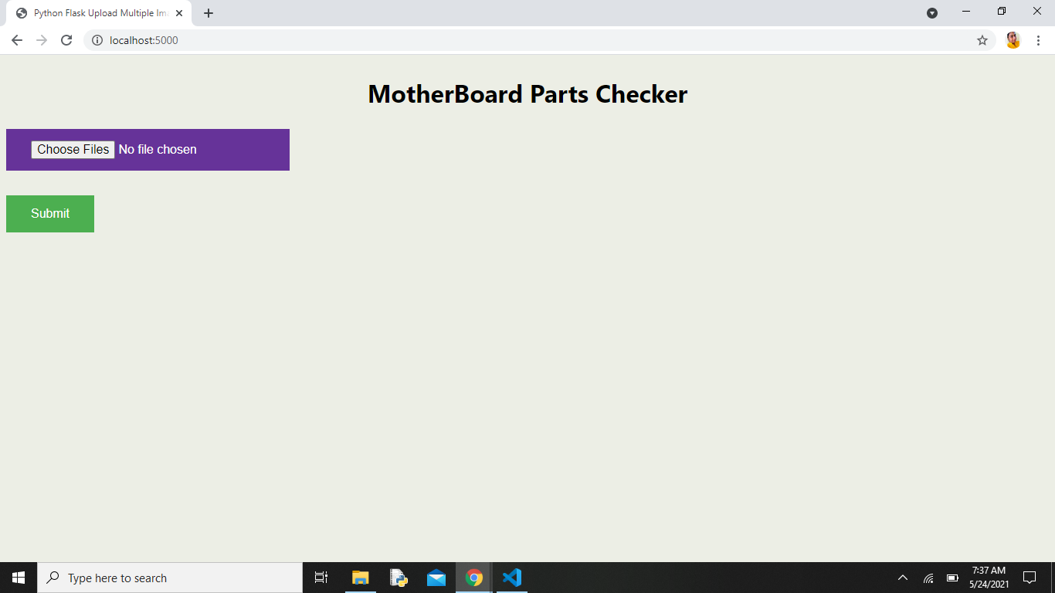

Figure 1

* The Figure 1 is the initial page of the output.

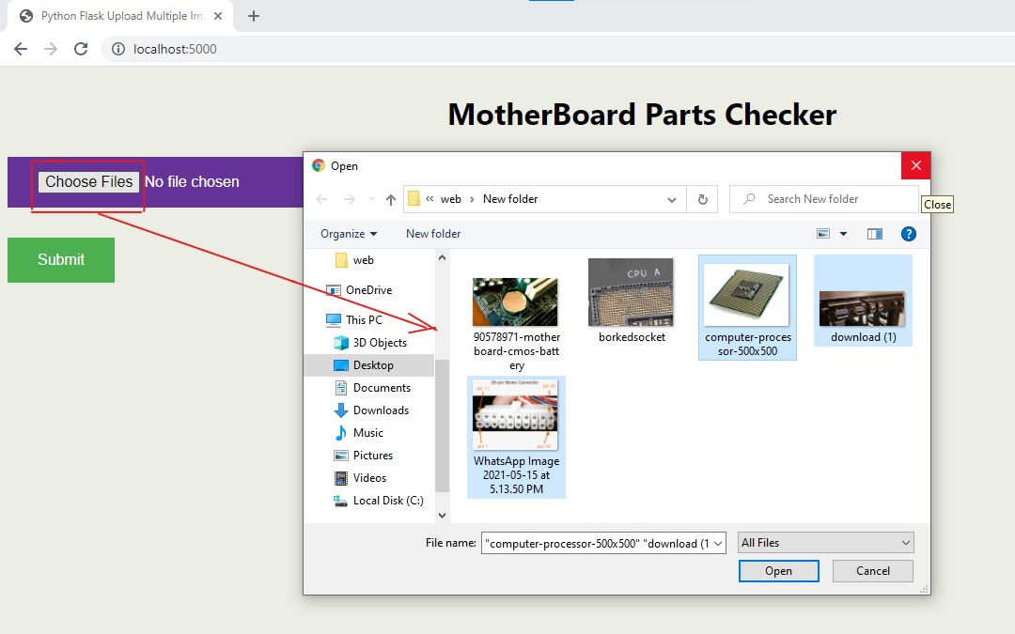

Figure 2

* Choose the file (Component of motherboard to be tested) as shown in figure 2.

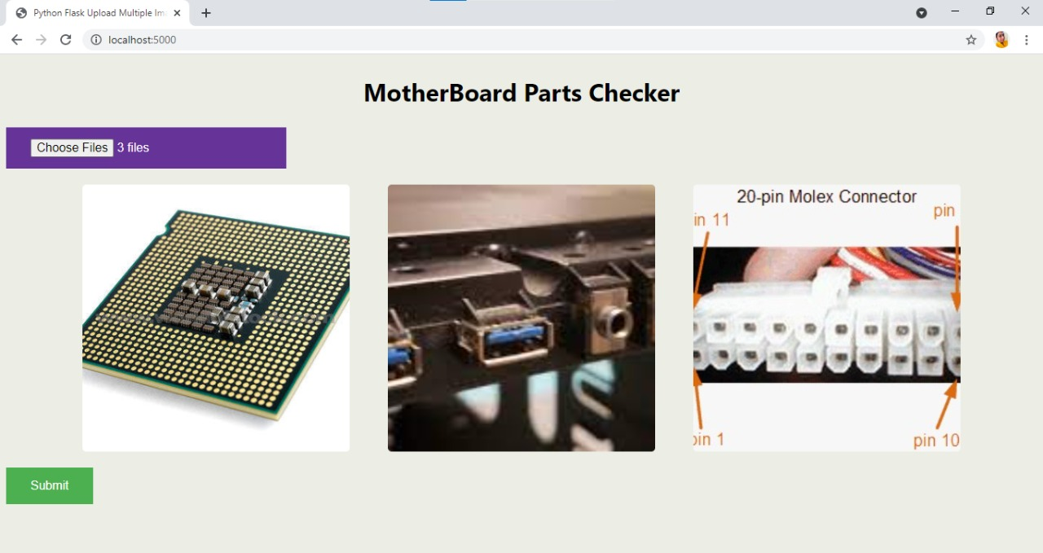

Figure 3

* The respective chosen images/ files are displayed on the web page as shown in figure 3, after submitting these images/files that have been chosen will be tested to make analysis that whether the image/file given is working or non-working component of the motherboard.

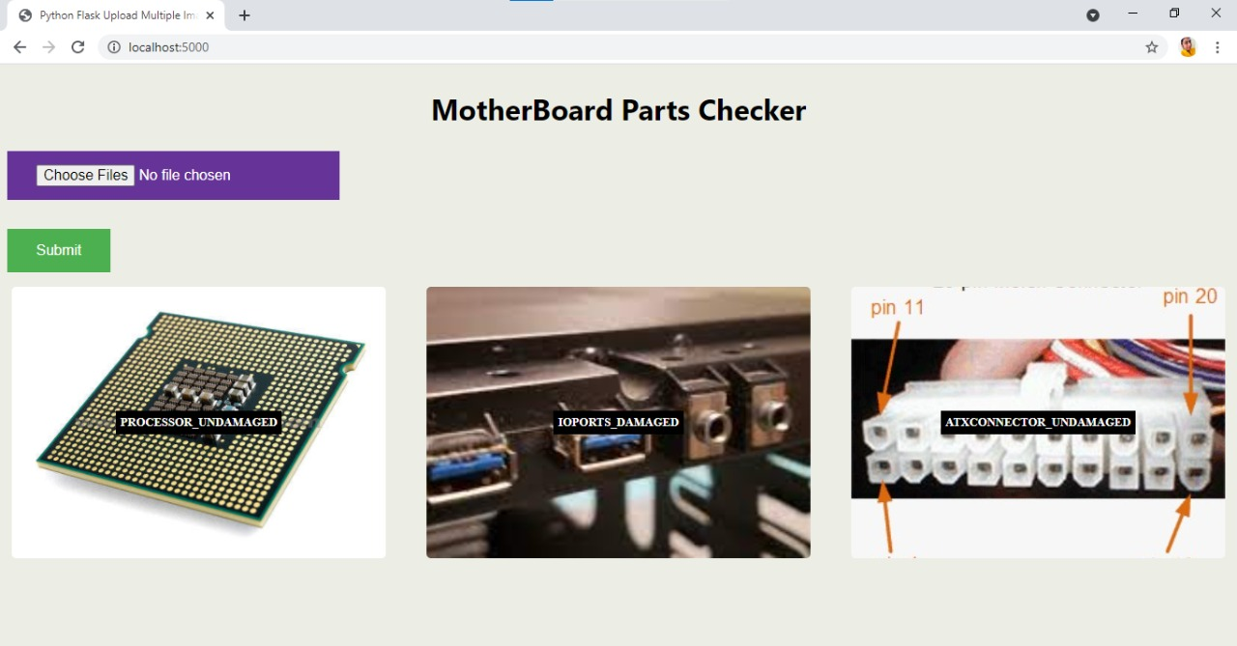

Figure 4

* After submitting the files i.e. after testing happens, we can see the output that the component is working or non-working(damaged/un-damaged) of the motherboard as shown in figure 4.

**Conclusion:** The issues of managing E-waste in India differ significantly from those in other industrialised and developing countries. Rapidly increasing E-waste volumes, both domestically generated as well as through imports.

There are no precise estimates of how much E-waste is generated and recycled. Low awareness of the dangers of improper E-waste disposal among manufacturers and consumers.

**Recycling of e-waste:** Recycling WEEE is an important subject not only from the view point of waste treatment but also in terms of recovery of valuable waste materials. Mechanical/physical processing provides an alternative means of recovering valuable materials but several difficulties exist. The main difficulty, industries have to afford is the separation of the different material in WEEE. This problem leads to several approaches to optimize the process.

**Reuse of e-waste:**It’s interesting that in many sectors we hear the terms – REUSE, RECYCLE or REDUCE Unfortunately, the e-waste problem is not one that is going to reduce anytime soon so we have to look to other options – Reuse or Recycle.

e-Waste Repurposing (Reuse or Remarketing) is a circular economy solution that involves repurposing non-data-holding electronic devices or electronic assets that have had their data deleted, either internally or externally, to give them a second or third life.

We have gone through the E-waste methodologies that are previously implemented. Most of the implementation is not identifying the working component of the E-waste produced. But the methodology we implemented, will take the help of Deep learning Algorithm and will identify the damaged parts that are present in an Electronic device i.e., Mother board and identify the parts which are working even there is a failure in Device. This methodology brings an evolution in industries and can able to increase the efficiency of the Electronic device.

**FUTURE ENHANCEMENT:**

* Using this technology we can add bounded boundary to the predicted components of the motherboard. For instance, if the component is not damaged i.e. working then green bounded boundary is displayed on the image; if the component is damaged then a red bounded boundary is displayed on the image.
* Not only e-waste but also home appliances also predicted using this technology.

**References:**

* Gupta Reena, Sangita and Kaur Verinder for Electronic Waste: A Case Study
* Abhijit Paradkar ME Computer Engg student, Deepak Sharma Associate Professor for Waste Recycle Management System based on Product Barcode
* Shagun, Ashwani Kush, and Anupam Arora for Proposed Solution of e-Waste Management
* G. Gaidajis, K. Angelakoglou and D. Aktsoglou for E-waste: Environmental Problems and Current Management
* DIT. Environmental management for Information Technology industry in India, Department of Information Technology, Government of India, 122-124 (2003)
* Radha G. A Study of the Performance of the Indian IT Sector’ at www.nautilus.org (2002)
* Violet N. Pinto. E-waste hazard: The impending challenge, Indian J Occup Environ Med., 12(2), 65–70 Aug (2008)
* Sinha Satish. Sustainable E-waste Management.,Toxic link 3-Mar,(2010) Retrieved from: http://www.toxicslink.org/art-view.php?id=134
* Dwivedy M., Mittal R.K., Future trends in computer waste generation in India, Waste Management, (30), 2265-2277 (2010)
* Singh S.K., The diffusion of mobile phones in India, Telecommunications Policy, 32, 642-651(2008) 7. Kumar Ranapati and Tripathi Saumya, “ElectronicsHi_Tech-Highly Toxic” India, Green Peace (2007)